PART B – SOFTWARE PROJECT MANAGEMENT PLAN

PROBLEM DEFINITION

NAME OF THIS CAPSTONE PROJECT
The official name of this project is “Online Assessment and Testing System”. The project code is “OATS”.

PROBLEM ABSTRACT
In order to meet the great market demand for online assessment and testing tool and to overcome the weaknesses of existing products, this project is to build up an online tools that allow teachers to create online tests in convenient way. Teachers can create tests by drag and drop contents, duplicate, reuse or search existing tests. After creating tests, teachers can invite students to conduct the assessment. Teachers can view reports about students and assessment. Students can keep track on their results.

PROBLEM OVERVIEW

The Current Systems
At this time, in Vietnam, there are a great number of online assessment and testing websites. Some of the most popular are listed below:
Open-Source Moodle (https://moodle.org): One of the most popular e-learning systems which offer various types of facilities for teaching and learning. In order to enrich the content and diversify learning methods, teachers can compose different types of exercises such as: assignments, quizzes, practical exams, and final exams. However in online testing features, drawbacks of the old system is revealed, it requires a lot of repetitive tasks to create and edit tests, reuse is not feasible.
http://www.vnschool.net/testonline: This website offers free tests to learners with varied content by subject. However, the out of date content and lack of interactive manipulation method have led the system unable to attract users.

The Proposed System
The system is an online testing tool for teachers and students that provide a totally new and most efficient way to create, edit and assessment tests online. Users will get a completely different experience with various types of drag and drop operations and with many pre-defined testing templates.
More precisely, the system is composed of three main components:
- Test tools for teachers: provide features related to creating, editing tests, reuse existing questions; through student and other teachers invitation activities, constructing a bridge between educators and students who want to join tests.
- Test tools for students: provide facilities for students in order to do tests with contents have been compiled by the teachers.
- Reporting tools: offer teachers convenient ways to monitor test result of students, assessment and thus review and evaluate student’s progress.

Boundaries of the System
At the beginning, on account of the limited time of the project, the system will focus on providing online testing as the main feature.
Functions will be implemented in this version include:
- For teachers to have set of power drag and drop tools with to create, manage tests, invites students and other teachers join the test, monitoring student test result to assessment.
- For students to enroll in tests, view available tests, do test and get report of testing result. Students can feedback or comment directly to teachers and administrators.
Furthermore, due to lack of time, this version will be presented with the absence of some functions such as:
- Types of question ( support six types )
- Personal profile page for each teachers, student.
- Chat system.
- Multiple language contents translator.

Development Environment
Product will be the web-based application which is developed under the following hardware and software environment:
Hardware environment:
- 4 personal computers with appropriate environment for developing and testing
Minimum configuration: 2GB of RAM, Core 2 Duo 2.0 GHz.
Software environment:
- Operating system: Window 7.
- Development language: C#
- Framework: ASP.NET MVC 4.0.

PROJECT ORGANIZATION

SOFTWARE PROCESS MODEL
SCRUM MODEL
The Waterfall model was not working well for our project and we decided to use the Scrum model as the framework to move over to the Agile process.

OVERVIEW DIAGRAM

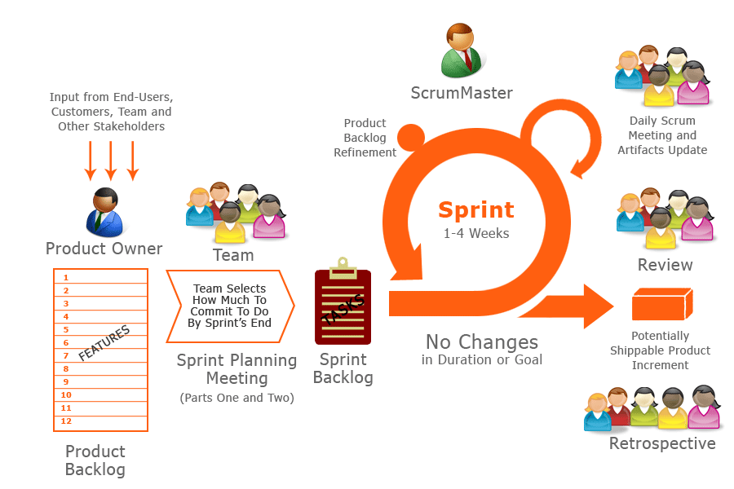

A sprint’s duration is normally about 2 to 4 weeks. However, because of the project characteristics, we decide to make progress in series of sprints which are time boxed iterations in one week. At the beginning of one sprint, through sprint planning meeting, all team members will discuss together to define sprint backlog which is suitable to be completed within a week. Daily meeting and online conference are used to manage all activities.

ROLES AND RESPONSIBILITIES
No. | Full name | Team Role | Scrum Team Role | Responsibilities
1 | Nguyễn Huy Hùng | Project Manager | Product Owner | - Outline work in scrum backlog  - Prioritize work  - Answer question and deliver direction
2. | Huỳnh Minh Tú | Team Leader | Scrum Master | - Facilitate productivity – maximize team performance  - Complete all individual work
3. | Nguyễn Đức Tân | Team Member | Scrum Team Member | - Commit individual product on time  - Support each other to complete team work
4 | Bùi Tường Thi | Team Member | Scrum Team Member | - Commit individual product on time  - Support each other to complete team work
5 | An Ngọc Anh | Team Member | Scrum Team Member | - Commit individual product on time  - Support each other to complete team work
Product Owner, in this project is also Project Manager who supports the whole team by outlining works in the scrum backlog, prioritizing it and being available to answer questions and deliver direction.
Scrum Master has responsibility to do everything he can do to facilitate productivity – address needs of the team and contribute to Product Owner to maximize team performance. As a real team player, he is required to complete all individual work.
Scrum Team Member is expected to be self-organized, cross-functional with high adaptability. All members have the right to do anything within the boundaries of project to reach the sprint goals and have responsibility not only to commit their individual product on time but also to support each other to ensure team can complete its work.
There are no fixed term for Team members – depend on time and demand of project, a member can play role of programmer, software architect, analyst, tester, QA expert, GUI designers, etc.

TOOLS AND TECHNIQUES

For Development
- Visual Studio 2012: Use to code software modules.
- MS SQL Server 2012 and SQL Management Tool: Use to create database for application.
- IIS Express: Use as web server.
- Integration Framework using MVC4, ADO.NET Entity Data Model.

For Management
- Tortoise SVN: Source version control.
- Google Code: Connect, synchronize source code and documents.
- MS Excel: Sprint Backlog.
- Beyond Compare: Manage changes in source files.

For Communication
- Skype chat system

PROJECT MANAGEMENT PLAN

TASKS
At the beginning of each sprint (Sprint Planning Meeting), based on Product Backlog and discussion with Project Owner, team will together put all the prioritized tasks to be assigned and create Sprint backlog document. This document also is task list for each sprint.
Product Backlog and Sprint Task List:

Product Backlog
No. | Task description | Type | Assign To
1 | Prototype for Assessment Page | Design
2 | +Tab List | Design | Tan
3 | +Tab Week | Design | Tan
4 | +Tab Day | Design | Tan
5 | Prototype for Test Page | Design
6 | +Statistic Tests | Design | Tu
7 | +New Tests | Design | Tu
8 | +Assignment Tests | Design | Tu
9 | Prototype for Appointment | Design
10 | +For Student | Design | Thi
11 | +For Educator | Design | Thi

No. | Task description | Type | Assign To
1 | Report 1 | Doc | TanND
2 | Tests & Assessment
3 | +List Recent Tests | Code | TanND
4 | +List Running Tests | Code | TanND
5 | +List Tests on Month tab | Code | TanND
6 | New Tests Page
7 | +Create tests function | Code | TuHM
8 | +Reuse tests function | Code | TuHM
9 | +Import tests function | Code | TuHM
10 | Searching function
11 | +Search on tests page | Code | AnhAN
12 | +Search on student page | Code | AnhAN
13 | +Search on teacher page | Code | AnhAN
14 | Appointment function
15 | +Appointment for student | Code | ThiBT
16 | +Appointment email for student | Code | ThiBT
17 | +Appointment for teacher | Code | ThiBT
18 | +Appointment email for teacher | Code | ThiBT

No. | Task description | Type | Assign To
1 | Report 2 - Project management plan | Doc | TanND
2 | Report 2 - Coding Convention | Doc | TanND
3 | Tests & Assessment
4 | +List Tests on Month Tab | Code | TanND
5 | +List Tests status on schedul/calendar | Code | TanND
6 | New Tests Page
7 | +Create tests function | Code | TuHM
8 | +Reuse tests function | Code | TuHM
9 | +Import tests function | Code | TuHM
10 | Report 2 - Problem definition | Doc | TuHM
11 | Report 2 - Project organization | Doc | TuHM
12 | Appointment function
13 | +Appointment for student | Code | ThiBT
14 | +Appointment email for student | Code | ThiBT
15 | +Appointment for teacher | Code | ThiBT
16 | +Appointment email for teacher | Code | ThiBT
17 | New Tests Page
18 | +Setting Apply function | Code | ThiBT
19 | New Tests Page - Invitation function
20 | +List Student & Teacher | Code | AnhAN
21 | +Create Invitation | Code | AnhAN
22 | +Add user in Invitation | Code | AnhAN
23 | +Delete user in Invitation | Code | AnhAN

RISK ASSESSMENT
Risk assessment:

Risk | Source | Risk Level | Control | Remediation | Status
Schedule Risk | Wrong time estimation | High
 | Resources are not tracked properly. All resources like members, systems, skills of individuals etc. | Medium
 | Failure to identify complex functionalities and time required to develop those functionalities. | Medium
 | Unexpected project scope expansions. | Medium
 | New system interfaces (semantic interpretation errors) | Medium
Operation Risk | Failure to address priority conflicts | High
 | Failure to resolve the responsibilities | Medium
 | No resource planning | Medium
 | No communication in team. | High
 | Allowing out-of-space conditions to occur | Medium
 | Team members misunderstanding | Medium
Technical Risk | Continuous changing requirements | High
 | No advanced technology available or the existing technology is in initial stages | Medium
 | Product is complex to implement | Medium

DELIVERABLES
No | Deliverable | Delivery date | Delivery location | Note
1 | Introduction Document | 2013.05.20 | FU – CMS | Report No.1
2 | Software Project Management Plan | 2013.05.27 | FU – CMS | Report No.2
3 | Software Requirements Specification | 2013.06.08 | FU – CMS | Report No.3
4 | Software Design Description | 2013.06.22 | FU – CMS | Report No.4
5 | Software Test Documentation | 2013.07.27 | FU – CMS | Report No.5
6 | Software User’s Manual | 2013.08.19 | FU – CMS | Report No.6
7 | Completed version of Report No.1 to Report No.6 – Soft copy | yyyy.mm.dd | Classroom  FU – CMS | Final version
8 | Completed version of Report No.1 to Report No.6 – Hard copy | yyyy.mm.dd | Classroom | Final version
9 | CD contains all Source code and installable system | yyyy.mm.dd | Classroom | Final version

* For each sprint, deliverables is potentially shippable product, which can be a part of documents or runnable software application which is implementation of some program features.

ALL MEETING MINUTES
Prefer to appendix.

CODING CONVENTION
Prefer to appendix.

